Name: _____________________________________________________ Date: _________________ Period: _______
Lesson 1.2.2 Problems 1-70 to 1-74
1-70. Imagine that you have a bag containing 10 marbles of different colors. You have drawn a marble, recorded its color, and replaced it fifty times, with the following results: 9 purple, 16 orange, 6 yellow, and 19 green marbles. Make a prediction for how many marbles of each color are in the bag. Show all of your work or explain your reasoning.

1-71. A fair number cube with the numbers 1, 2, 3, 4, 5, and 6 is rolled.
a. What is the probability of getting an even number?

b. What is the probability of getting a factor of 6?

1-72. Ramon is saving $7.75 per week to buy a new cell phone. The phone he wants costs $125.00. For how many weeks will he need to save his money? First, estimate your answer. Then figure out the actual number of weeks.

1-73. If 18 inches is equal to 1 feet, how many feet is a 36-inch board? A 72-inch board? A 144-inch board?

1-74. Read this lesson’s Math Notes box about scaling axes. Then write the missing numbers on each of the incomplete axes.
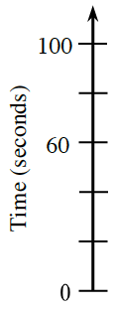
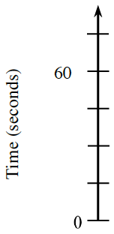
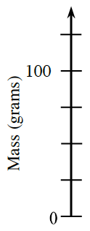
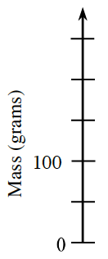
a. b. c. d.

